Vital Dashboard: After Running The Refresh, follow the below link to be sure you see updated activity.

<http://mp-ssr-fa01.corp.net.bcbsaz.com/Reports_SS01P/Pages/Report.aspx?ItemPath=%2fReports%2fDSAS%2fHMS%2fHMS+VITAL+Operational+Dashboard>

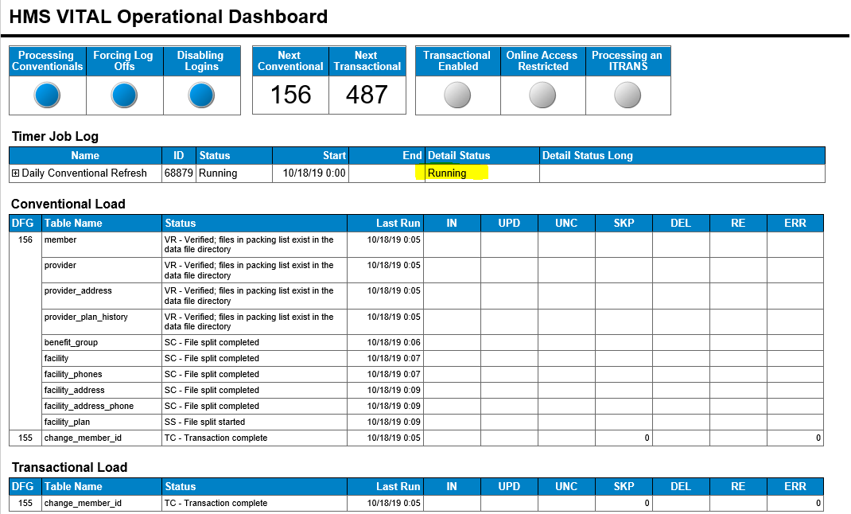

* If you receive an email with the subject line “*HMS automated refresh process errors*”

RDP into mp-hms-a05 with your ADM credentials

* Go to D:\vital\ccmsserv\ccmsrcvr

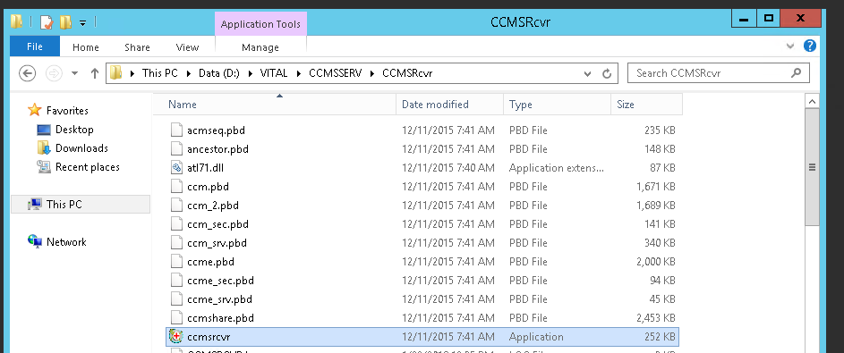

* + Enter username and password *‘if necessary’*:
    - Go to G:\OPS\Shifts\Logins.xlsx – ***HMS Error***
    - Select **ccms prod** in the drop down
    - Login

Let it run to completion (Login screen may appear again)

Once the program logs out and returns you to the desktop verify that the log in screen appears as expected.

**Verification the error resolved**:

<http://vitalplatform.prod.azblue.com:8080/VITALPlatform/ui.html>

* If login screen appears the issue has been fixed.

*Note: Only send out email upon error received. No need to send out email during ‘After Prod patching’ checkout*

**Send an email to DSAS stating the issue is resolved**:

Conventional timer

(*Change the date in the subject line*)